  For more information | “The European Union is made up of 28 Member  “The European Union is made up of 28 Member  States who have decided to gradually link together their know-how, resources and destinies. Together, during a period of enlargement of 60 years, they have built a zone of stability, democracy and sustainable development whilst maintaining cultural diversity, tolerance and individual freedoms.  The European Union is committed to sharing its achievements and its values with countries and peoples beyond its borders”.  The Twinning project is implemented by the Finnish Education Evaluation Centre (FINEEC), the Estonian Higher Education Quality Agency (EKKA) and the Ministry of Education of the Republic of Azerbaijan and funded by the European Union with a budget of 1.3 million Euro.  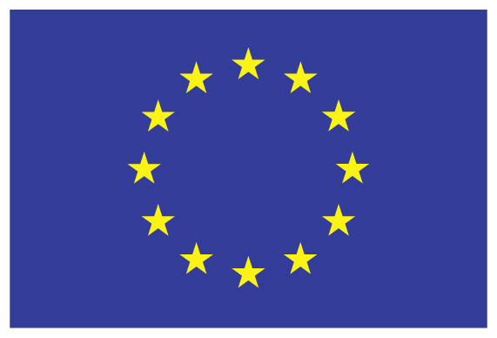  ______________________________________  The views expressed in this publication do not necessarily  reflect the views of the European Commission.
For more information:  Delegation of the European Union  to the Republic of Azerbaijan  Landmark III, 11th floor  90A Nizami street  AZ 1010 Baku, Azerbaijan  Tel: +994 12 497 20 63  Fax: + 994 12 497 20 69  Email: Delegation-Azerbaijan@eeas.europa.eu  Website:  www.eeas.europa.eu/delegations/azerbaijan  Ministry of Education of  the Republic of Azerbaijan  Mr. Tofig Ahmadov – RTA Counterpart  Ministry of Education, 49 Khatai Avenue  AZ1008 Baku, Azerbaijan  Tel: +994 12 599 11 55 (ext. 5113)  Email: tofig.ahmadov@edu.gov.az  Website: www.edu.gov.az  Office of Resident Twinning Adviser (RTA)  Mr. Reijo Aholainen – RTA  Ms. Aytaj Atakishiyeva – RTA Assistant  Ministry of Education, 49 Khatai Avenue  AZ1008 Baku, Azerbaijan  Tel: +994 12 599 11 55 (ext. 5229; ext. 5145)  E-mail: aholare1@gmail.com;  aytajatakishiyeva@gmail.com |  | ENPI Annual Action Programme 2011 Azerbaijan
TWINNING PROJECT

“Support to the Ministry of Education of the Republic of Azerbaijan for Further Adherence of the Higher Education System to the European Higher Education Area”

AZ/14/ENP/OT/31

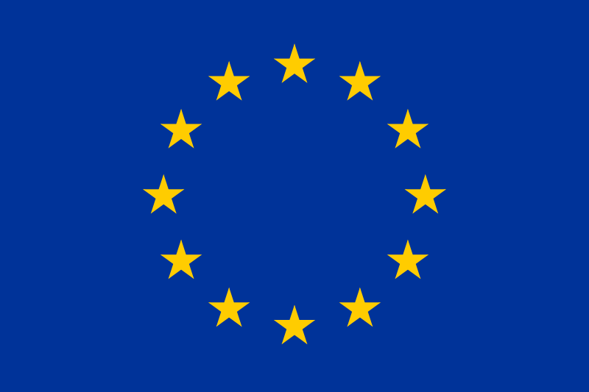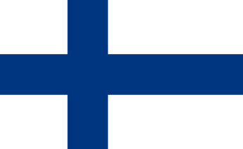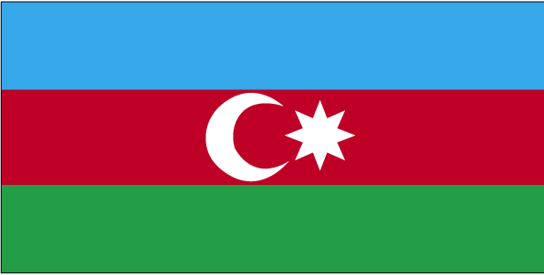

Background information  Azerbaijan joined the Bologna Process in 2005 and has since progressed with the implementation of the objectives of the European Higher Education Area (EHEA). Azerbaijan has gradually introduced a credit system for the Bachelor and Master level higher education and preparations for the Doctoral level are under discussion. Most universities have established units for internal quality assurance and a National Qualifications Framework (AzQF) has been submitted to the Cabinet of Ministers for approval. The Twinning project should be instrumental for Azerbaijan’s successful adherence to the EHEA, and to furthering the reform of the Azerbaijani higher education system.  Overall objective and project purpose  The overall objective of the Twinning project is to enhance Azerbaijan's higher education through increased integration with the standards of the EHEA. The purpose is to increase the institutional capacities of the Ministry of Education and other key institutions of the Republic of Azerbaijan for the development of policies related to the Bologna process and the implementation of the EHEA objectives and reference tools. The implementation period of the project was started on 1st of September 2015 and will last two years, until the end of August 2017.  The Twinning project reflects the strategic objectives under the EU-Azerbaijan European Neighbourhood Policy Action Plan, where the European support is foreseen for the reform and modernisation of the education and training systems within the framework of Azerbaijan’s reform programme. | The Action Plan includes higher education sector reforms in line with the Bologna process principles of quality enhancement, improved accreditation system for higher education institutions, policy dialogue between EU and Azerbaijani and increasing international cooperation and mobility.  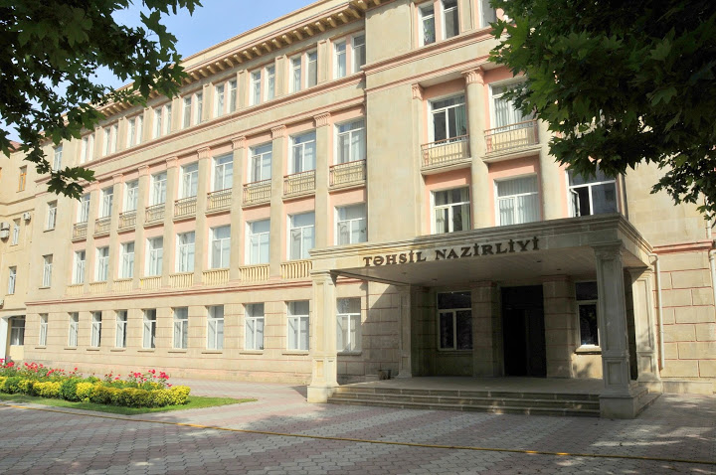  Expected Results  The project aims for concrete results in four areas. Most ambitious area is to develop the standards and guidelines for quality assurance in higher education in Azerbaijan in line with the European standards and also test them in practice with three Azerbaijan higher education institutions. The project will also construct a roadmap for the full implementation of new National Qualifications Framework in higher education in line with the European Qualification Framework. Third component is to enhance the coordination and networking capacity of the Ministry of Education and relevant stakeholders on the basis of good practice examples in the EHEA. Finally, the project will review current higher education regulations and draft concrete recommendations for adapting legislation relevant to quality assurance and higher education in Azerbaijan. | Key partners  The Twinning projects are based on institutional cooperation between EU member states and EU neighbour countries. The European partners in this project are the Finnish Education Evaluation Centre (lead Member State partner) and the Estonian Higher Education Quality Agency (Member State partner) as well as Azerbaijan partner is the Ministry of Education of the Republic of Azerbaijan. The beneficiaries of the project also include Azerbaijan higher education institutions and in the final analysis university students and the society and economy as a whole.  The Project Leaders are Ms. Helka Kekäläinen, the Vice President of the Finnish Education Evaluation Centre, Ms. Heli Mattisen, the President of the Estonian Higher Education Quality Agency and Mr. Emin Amrullayev, Head of Education Development Programmes Department of the Ministry of Education of the Republic of Azerbaijan. The human resources of the project consist of the Resident Twinning Adviser (RTA) Mr. Reijo Aholainen, the RTA Counterpart Mr. Ilham Humbatov, the two Twinning assistants and the 50 short term experts from Finnish and Estonian Evaluation Centres, Ministries and Universities as well as the project participants from the Ministry of Education of the Republic of Azerbaijan and Azerbaijan higher education institutions. The project budget covers over 470 European short term expert days for working together with Azerbaijan experts in Azerbaijan as well as study visits and internships to EU member states for Azerbaijan experts.

